Fig. 1. Early neonatal mortality according to birth weight (in grams) (A), gestational age (full weeks) (B) and Apgar score at 5 minutes of life (C).
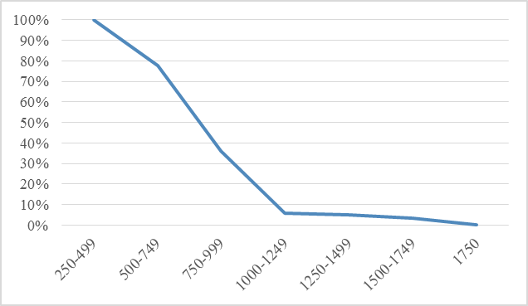
А
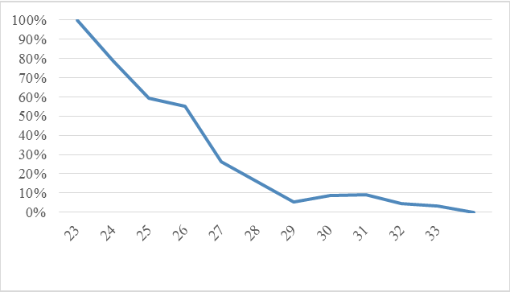
B
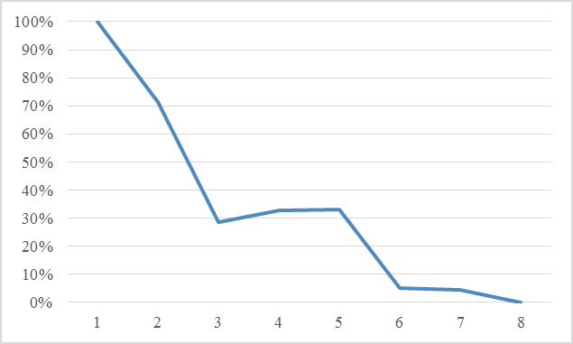
C

