Adenomyosis +  Slow myoma growth  (Uterine body volume up to 12 weeks) |  | Adenomyosis +  Progressive myoma growth (Uterine body volume more than 12 weeks)
Euendometrium | Adenomyosis focus | Euendometrium | Adenomyosis focus
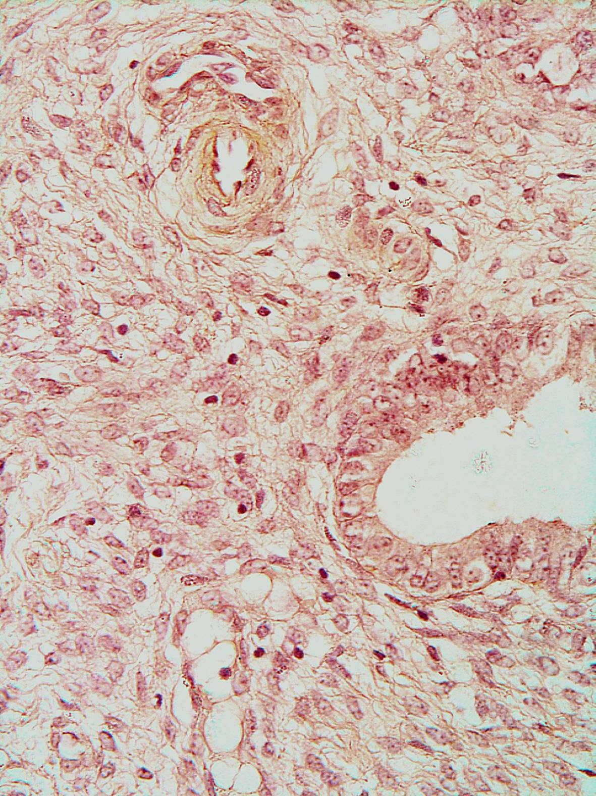 | 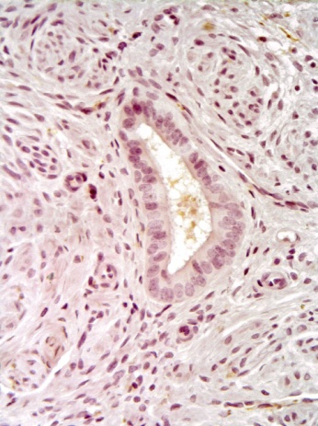 | 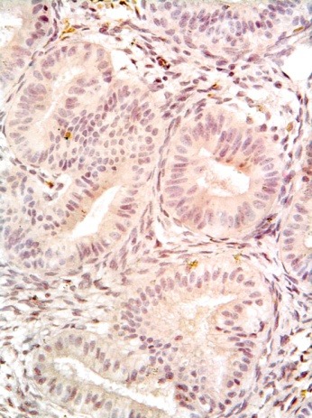 | 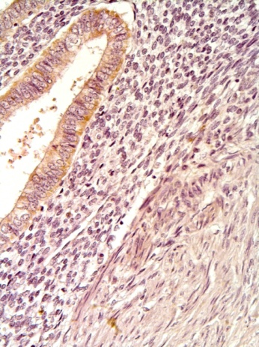
Fig. 1. HPSE-1 expression in euendometrium and adenomyosis foci in reproductive-age women with leiomyoma at proliferative phase of menstrual cycle.

