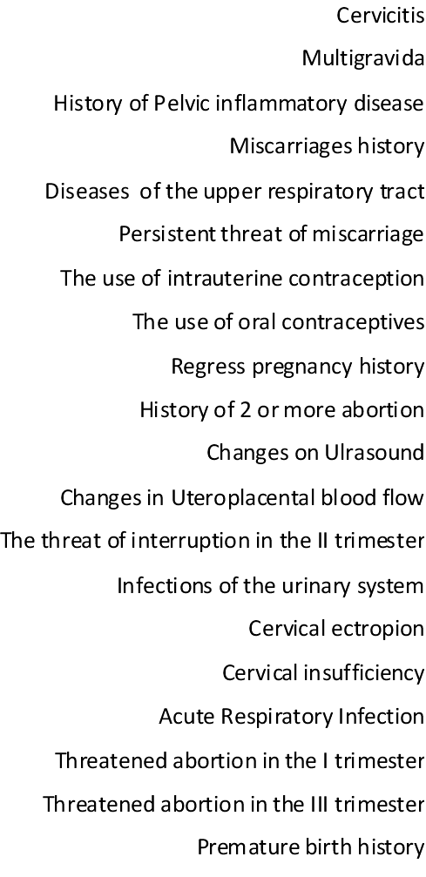
FIG 1 Relative risk of intraunerine infection

