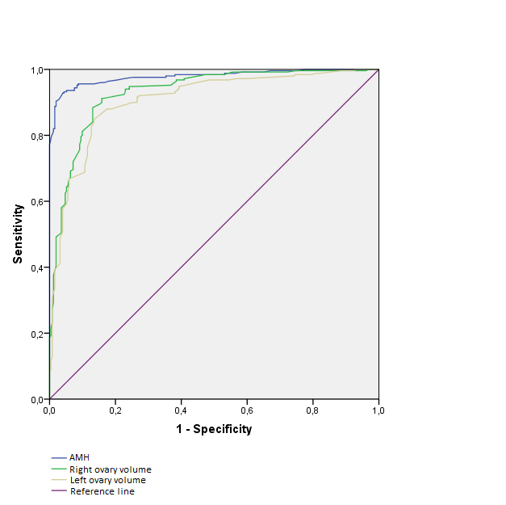

Picture 1. ROC-analyses, AMH level and ovarian volume significance estimation in PCOS diagnosis.

