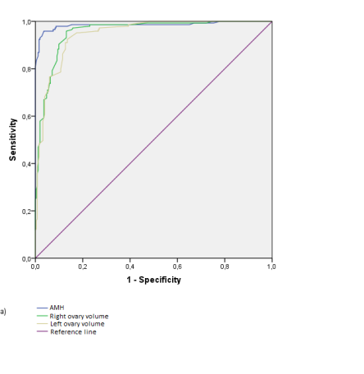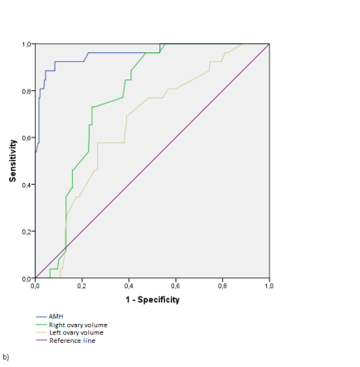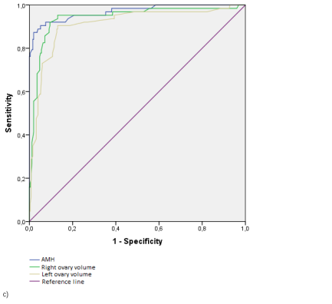

Picture 2. ROC-analyses, AMH and ovarian volume significance estimation in different PCOS phenotypes: а) phenotype А; b) phenotype В; c) phenotype D.