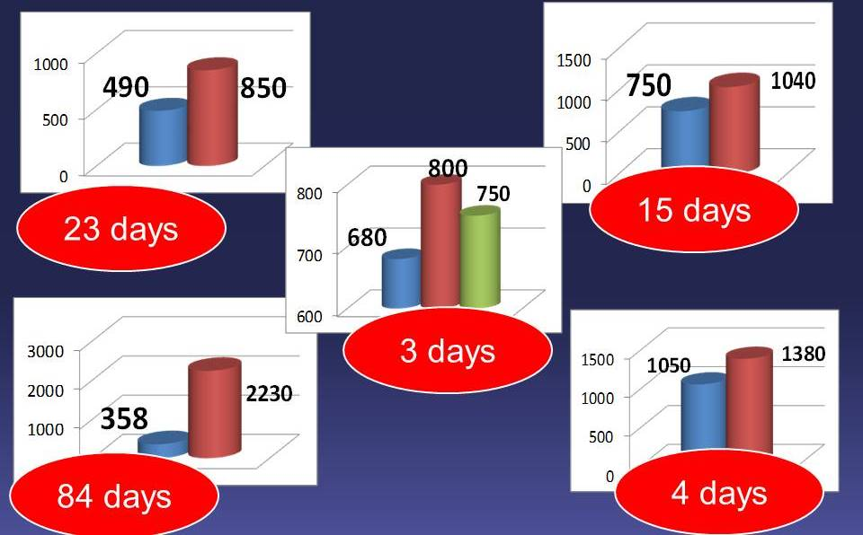

Figure 1. Outcomes of multifetal labor with delayed intertwin interval (mass (gram) and the duration of intertwine period (days))

