Fig 1. IVF outcomes in patients with different BMI
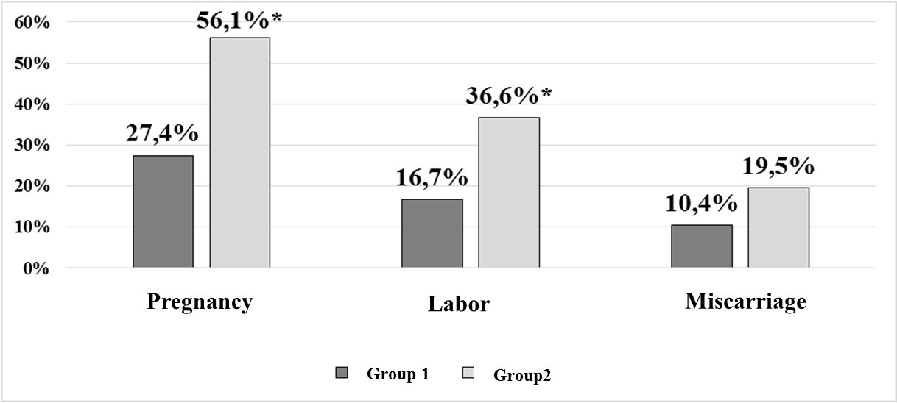
*р<0,05

