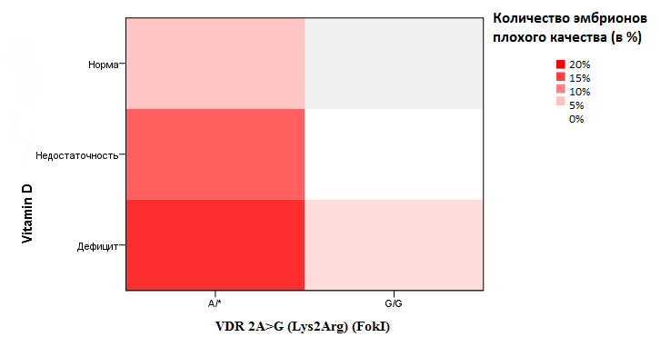
Pic. 2. Number of bad quality embryos (in %) depending on polymorphism of the VDR 2A>G (Lys2Arg) (FokI) gene and the level of vitamin D in blood serum
(* - allele А or G)

