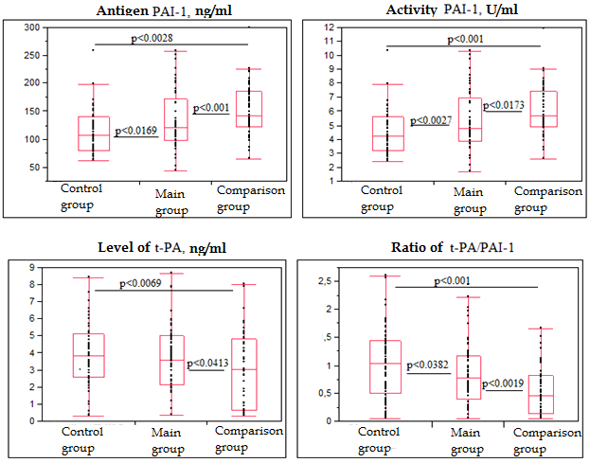
Figure 2. Specific fibrinolytic reactions in relation to LIT in comparison groups at 7-8 weeks of gestation.

PAI-1 – plasminogen activator inhibitor 1
t-PA – tissue-type plasminogen activator
LIT - lymphocyte immunotherapy

