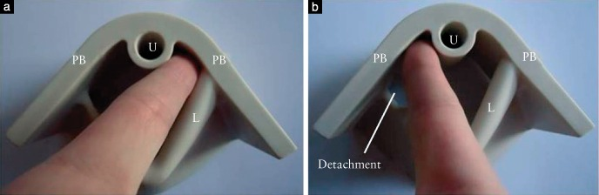

Figure. 3. Levator ani muscle palpation demonstrated using a model. (a) Normal left-side levator ani muscle (L) attachment. (b) Right-side avulsion. PB, pubic bone; U, urethra.

