Fig. 5 A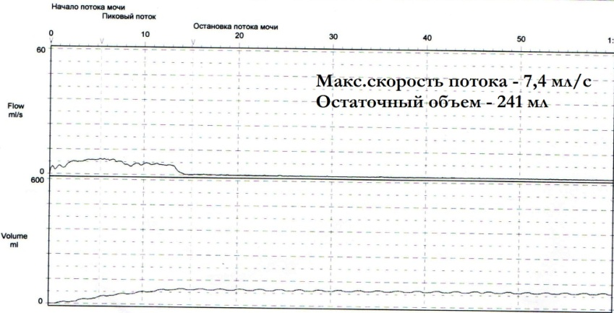

Max. urinary flow rate – 7,4 ml/s

Residual urine volume – 241 ml

Fig. 5 B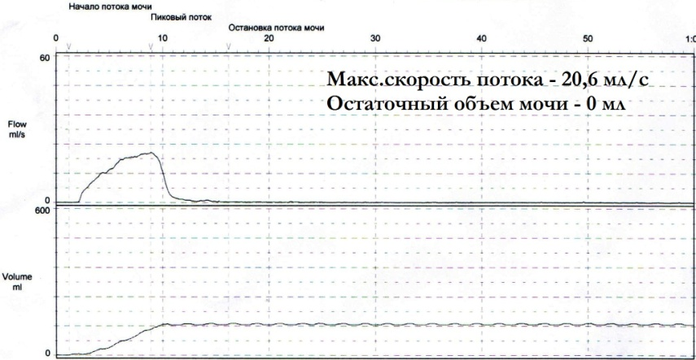

Max. urinary flow rate – 20,6 ml/s

Residual urine volume – 0 ml

Fig. 5 A. The patient of 65 years with POP, before the introduction of the pessary. During the uroflowmetry marked obstructive voiding type: reduced max. urinary flow rate (7.4 ml / s) environments. rate of urination and urine volume at miktsii. Fig. 5 B. The same patient after the introduction of the pessary. Restoration of normal indicators - non-obstructive urinary type: max. urination rate (20.6 ml / sec), and residual urine volume reduction to 0 ml.