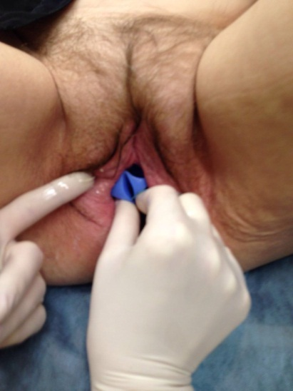
а b c
Fig. 6. The patient, 69 years old. Pelvic organ prolapse 3 stage. Figure a) before and c) after the introduction of the pessary.

