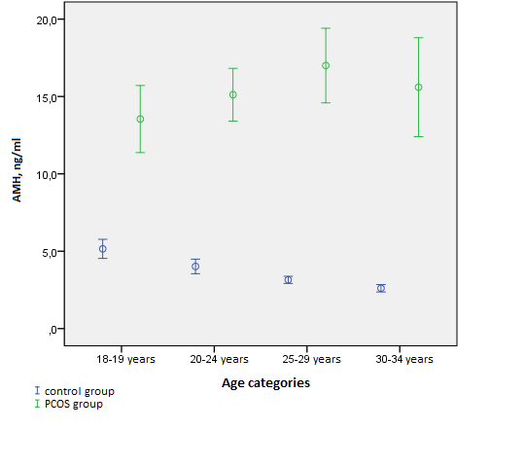

Picture 1. Mean AMH levels in different age categories.