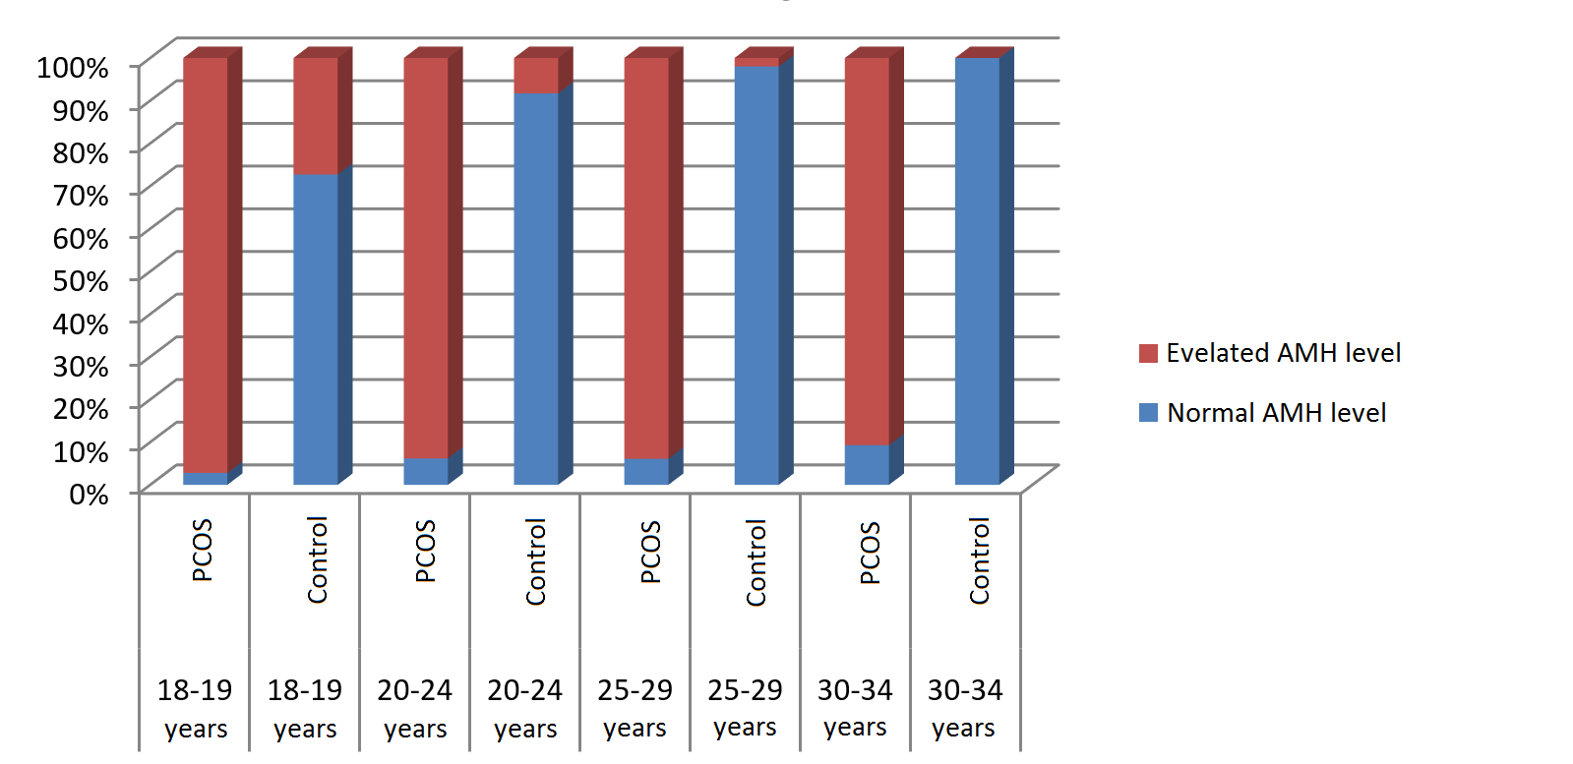

Picture 2. AMH elevations frequency in age subgroups.

