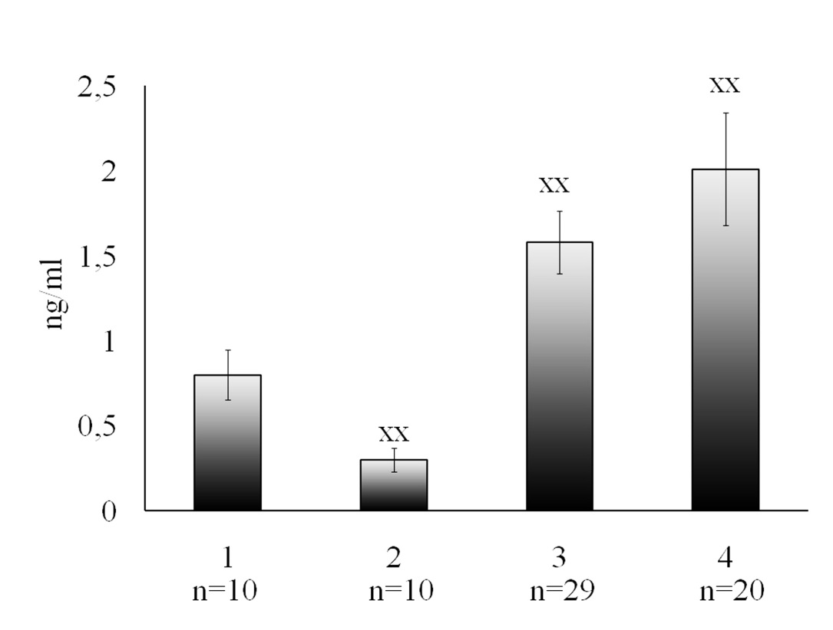
Fig.3 Soluble receptor 1 of epidermal growth factor in the control group, in case of threatened preterm labor, in case of physiologic labor and in case of preeclampsia
1 – Control
2 – Threatened preterm labor
3 – Physiologic labor
4 – Preeclampsia
хх – p< 0.01 as compared to the control group

