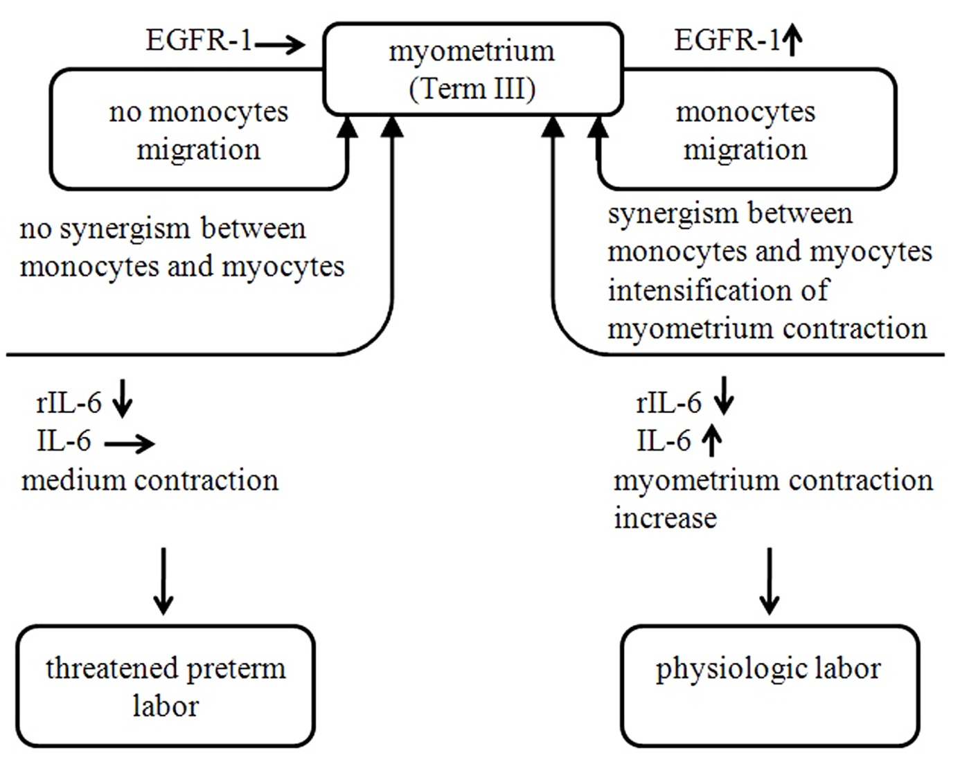
Fig. 4. Potential model explaining myometrium contraction degree in case of physiologic (term) labor and threated preterm labor.
Cytokine level:
- not changed
- increased
- decreased

