Fig. 1. Distribution of sexual partners of the study groups by the percentage of fragmentation
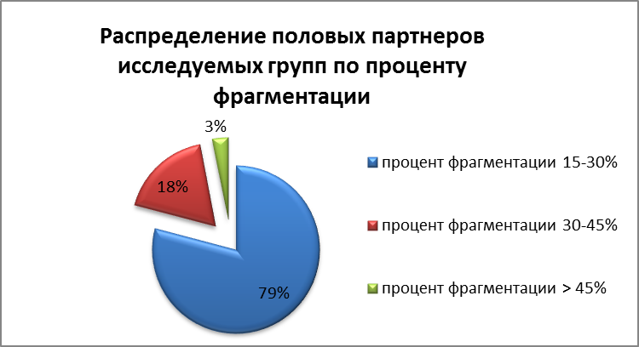

Inside:
Distribution of sexual partners of the study groups by the percentage of fragmentation
percentage of fragmentation 15-30%
percentage of fragmentation 30-45%
percentage of fragmentation >45%

