Fig. 1. Research design

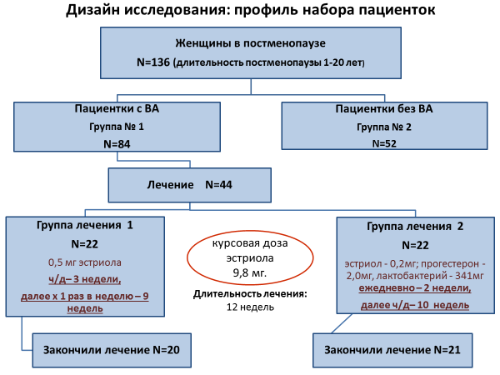

Text:
Postmenopausal women N = 136 (the duration of menopause 1-20 years)
Patients with VA Group 1 N = 84
Patients without VA group 2 N = 52
Treatment N = 44
Treatment Group 1 N = 22 0.5 mg estriol h / d - 3 weeks, then once a week 1 - 9 weeks
Finished treatment N = 20
Course dose of estriol 9.8 mg
Duration of treatment - 12 weeks
Group Treatment N = 2 22 estriol - 0.2 mg; Progesterone 2.0 mg, lactobacillus 341 mg daily 2 weeks, then b / d 10 weeks
Finished treatment N = 21

