Fig. 2. Level of relative expression of mitochondrial proteins in blood plasma microvysicles. White - the norm, black - miscarriage. A - Porin (VDAC1), B - mtDNA translation initiation protein (TFAM1), B - subunit 1 mitochondrial cytochrome c oxidase (MTCO1). The data are presented as the mean of three measurements ± the standard error of the mean, n = 12 for each group

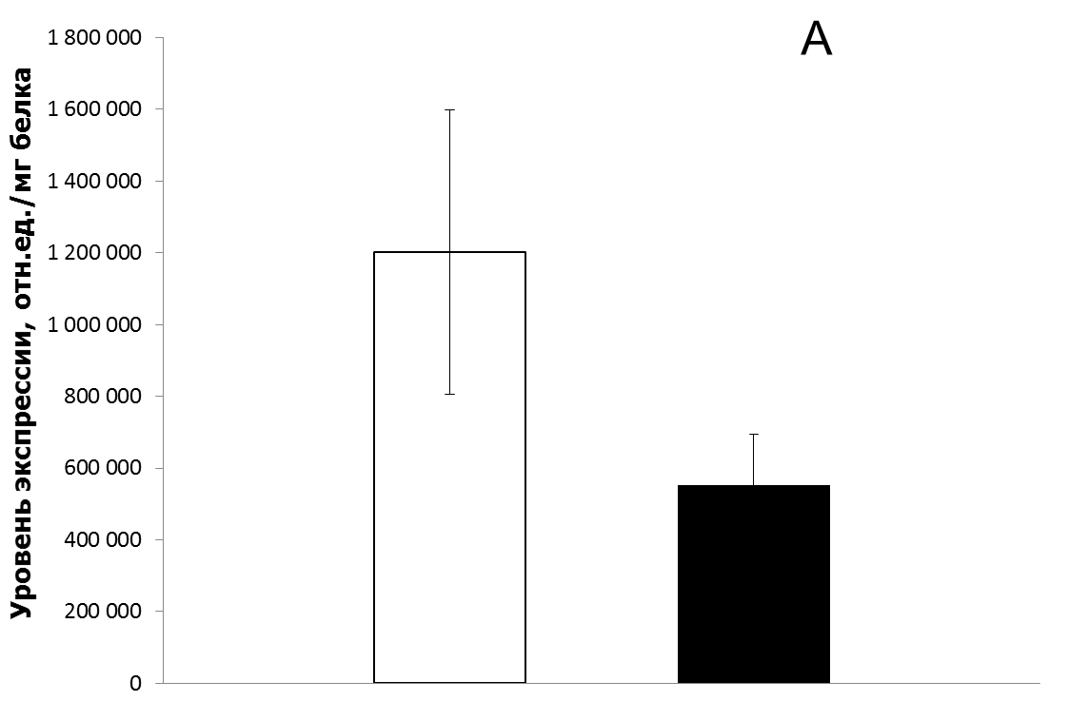 *р<0,01
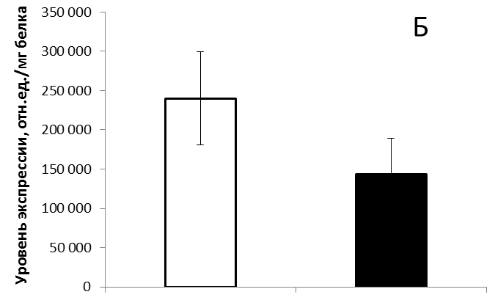*р<0,01
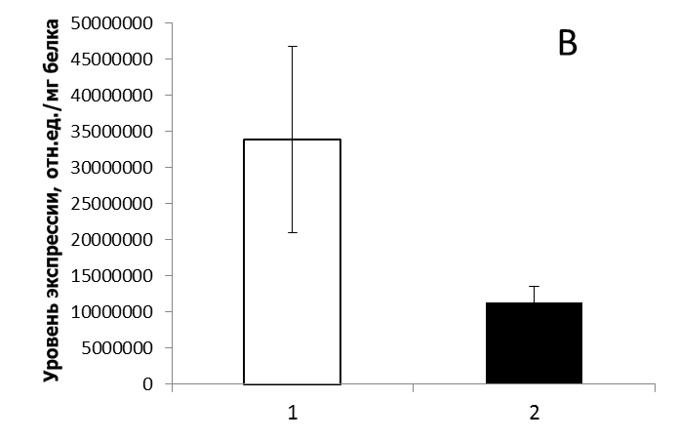 *р<0,01

