Figure 1. Modes of 3D NSG А) - surface rendering; B) - tomographic ultrasound imaging; C) and D) – multiplanar view
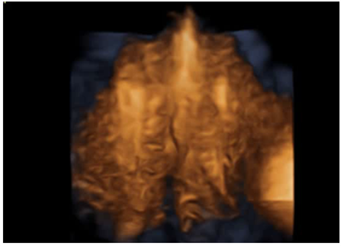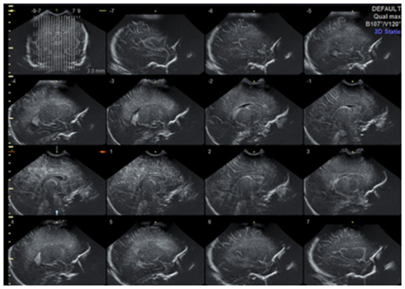
А
B
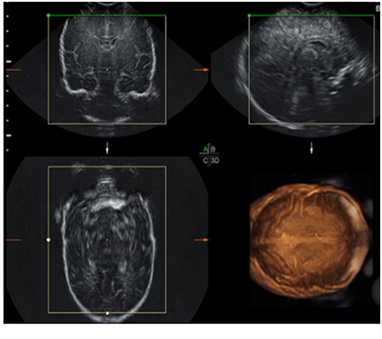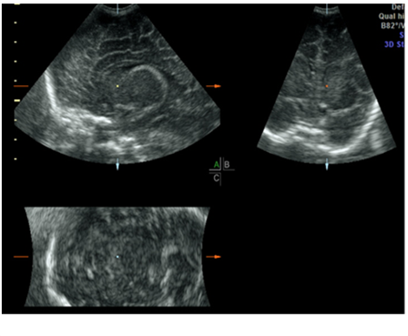
C
D

