Fig. 1. Patient disposition (CONSORT flow-diagram)
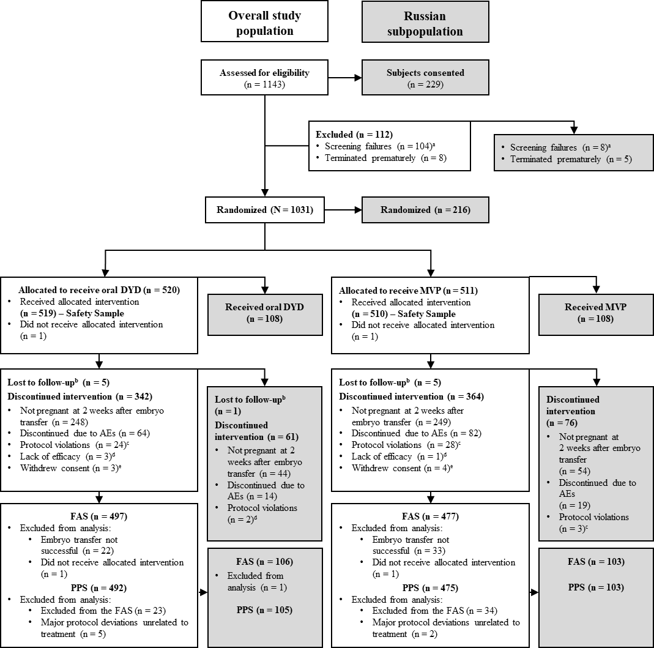
Reproduced from H. Tournaye et al. [19]. Published by Oxford University Press on behalf of the European Society of Human Reproduction and Embryology (ESHRE) online at: https://academic.oup.com/humrep/article/32/5/1019/2993661/A-Phase-III-randomized-controlled-trial-comparing?searchresult=1.
ªDetermined by inclusion/exclusion criteria; ^{b}Subject failed to return to the study site for scheduled visits and did not respond to telephone or written attempts to contact; ^{c}Anything that was in direct violation of the Clinical Study Protocol (e.g. inclusion/exclusion violation); ^{d}Subject failed to respond to the study drug at an acceptable level where the subject or the Investigator felt it was in the best interests of the subject to seek another treatment; ^{e}Subject decided to stop her participation in the study for any reason other than an AE, or was unable to complete the study as described in the Clinical Study Protocol (e.g. subject was relocating to another location).
AE, adverse event; DYD, dydrogesterone; FAS, full analysis set; MVP, micronized vaginal progesterone; PPS, per protocol sample.

