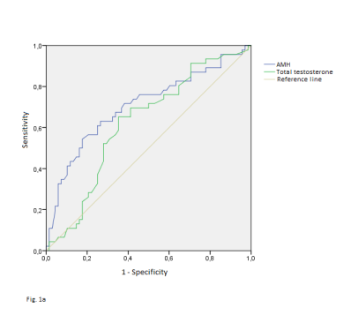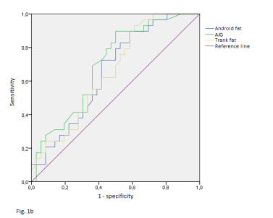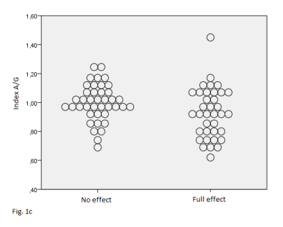

Fig.1.ROC-analyses of dependence of menstrual period restoration on: a) AMH and total testosterone levels; b) dual-energy X-ray absorptiometry; c) Index A/G distribution depending metformin effectiveness (0 – absence of effect, 1- menstrual period restoration).