Fig. 2. Features of fixing the reticular implant (Prof. JB Dubuisson)

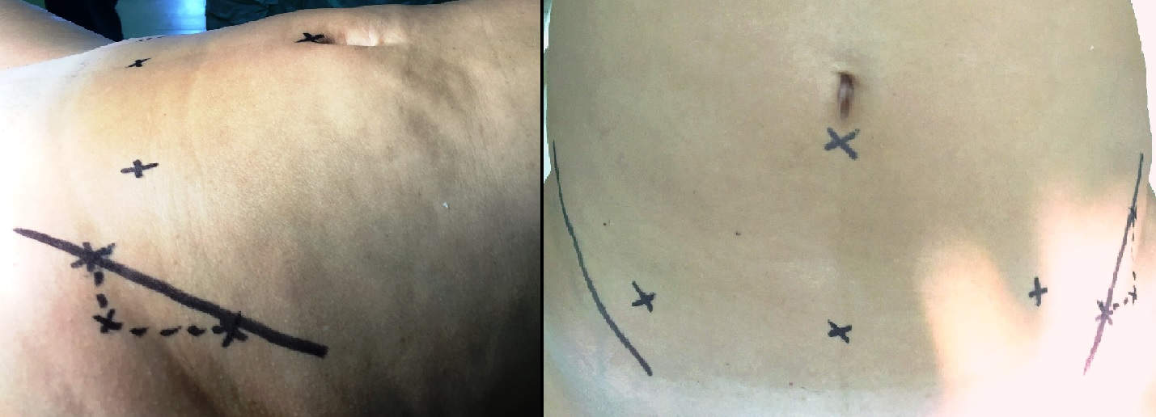
2 см
4 см

