Fig . 1 . Cost-effectiveness analysis for Model No. 1
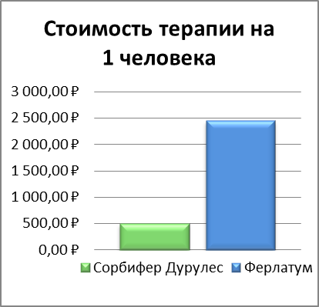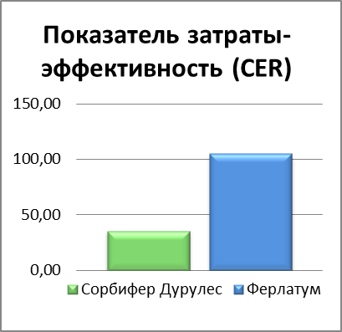

Text:
The cost of therapy for 1 person
Sorbifer durules
Ferlatum
Rub.
The "cost-effectiveness" ( CER )
Sorbifer durules
Ferlatum

