Fig . 5 . Averaging e nnye performance "cost - effectiveness b" for different iron preparations
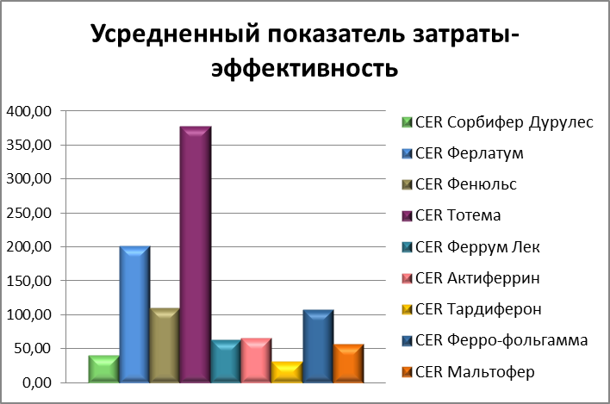
Text:
CER sorbent durules
CER ferrutum
CER phenuls
CER totem
CER ferrum lek
CER actinferrin
CER tardiferon
CER ferro-foil
CER maltofer

