Fig . 1. Outcomes of ART programs in patients of late reproductive age without preimplantation genetic screening (group 1) and patients of late reproductive age with preimplantation genetical screening (group 2), * p <0.05
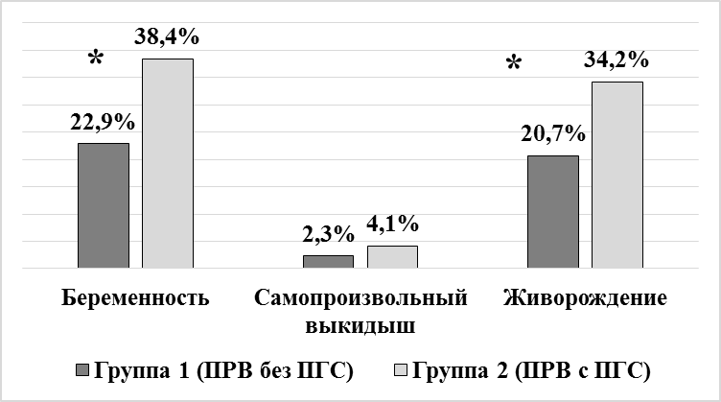
Text:
Pregnancy
Spontaneous miscarriage
Live birth
Group 1 (patients of late reproductive age without preimplantation genetic screening)
Group 2 (patients of late reproductive age with preimplantation genetic screening)

